UNITED STATES
SECURITIES AND EXCHANGE COMMISSION
Washington, D.C. 20549
FORM 8-K
CURRENT REPORT
Pursuant to Section 13 or 15(d)
of the Securities Exchange Act of 1934
November 10, 2025
Date of Report (Date of earliest event reported)
ARS Pharmaceuticals, Inc.
(Exact name of registrant as specified in its charter)
Delaware |  | 001-39756 |  | 81-1489190
(State or other jurisdiction  of incorporation) |  | (Commission  File Number) |  | (IRS Employer  Identification No.)

11682 El Camino Real, Suite 300  San Diego, California |  | 92130
(Address of principal executive offices) |  | (Zip Code)
Registrant’s telephone number, including area code: (858) 771-9307
11682 El Camino Real, Suite 120
San Diego, California 92130
(Former name or former address, if changed since last report)
Check the appropriate box below if the Form 8-K filing is intended to simultaneously satisfy the filing obligations of the registrant under any of the following provisions:

☐ | Written communications pursuant to Rule 425 under the Securities Act (17 CFR 230.425)
☐ | Soliciting material pursuant to Rule 14a-12 under the Exchange Act (17 CFR 240.14a-12)
☐ | Pre-commencement communications pursuant to Rule 14d-2(b) under the Exchange Act (17 CFR 240.14d-2(b))
☐ | Pre-commencement communications pursuant to Rule 13e-4(c) under the Exchange Act (17 CFR 240.13e-4(c))
Securities registered pursuant to Section 12(b) of the Act:
Title of each class |  | Trading  Symbol(s) |  | Name of each exchange  on which registered
Common Stock, $0.0001 par value per share |  | SPRY |  | The Nasdaq Stock Market LLC
Indicate by check mark whether the registrant is an emerging growth company as defined in Rule 405 of the Securities Act of 1933 (§ 230.405 of this chapter) or Rule 12b–2 of the Securities Exchange Act of 1934 (§ 240.12b–2 of this chapter).
Emerging growth company ☒
If an emerging growth company, indicate by check mark if the registrant has elected not to use the extended transition period for complying with any new or revised financial accounting standards provided pursuant to Section 13(a) of the Exchange Act. ☐

Item 2.02 Results of Operations and Financial Condition.
On November 10, 2025, ARS Pharmaceuticals, Inc. (the “Company”) announced its financial results for the quarter ended September 30, 2025 in the press release attached hereto as Exhibit 99.1 and incorporated herein by reference.
The information in this Item 2.02 of this Current Report on Form 8-K, including Exhibit 99.1, is furnished and shall not be deemed “filed” for purposes of Section 18 of the Securities Exchange Act of 1934, as amended (the “Exchange Act”), or subject to the liabilities of that, or otherwise subject to the liabilities of that Section, nor shall it be deemed incorporated by reference into any filing under the Exchange Act or the Securities Act of 1933 (the “Securities Act”), whether made before or after today’s date, regardless of any general incorporation language in such filing, except as shall be expressly set forth by specific references in such filing.
Item 7.01 Regulation FD Disclosure.
On November 10, 2025, the Company updated its corporate presentation for use with investors, analysts and others. The revised presentation is available through the Company’s website, and a copy of the presentation is attached as Exhibit 99.2 to this Current Report on Form 8-K.
The information in this Item 7.01 of this Current Report on Form 8-K, including Exhibit 99.2, is furnished and shall not be deemed “filed” for purposes of Section 18 of the Exchange Act, or otherwise subject to the liabilities of that Section, nor shall it be deemed incorporated by reference into any filing under the Exchange Act or the Securities Act, whether made before or after today’s date, regardless of any general incorporation language in such filing, except as shall be expressly set forth by specific references in such filing.
Item 9.01 Financial Statements and Exhibits.
(d)
Exhibit  Number |  | Description
99.1 |  | Press Release dated November 10, 2025
99.2 |  | Company Presentation dated November 10, 2025
104 |  | Cover Page Interactive Data File (embedded within the Inline XBRL document).

SIGNATURES
Pursuant to the requirements of the Securities Exchange Act of 1934, as amended, the registrant has duly caused this report to be signed on its behalf by the undersigned hereunto duly authorized.
 |  | ARS PHARMACEUTICALS, INC.
Date: November 10, 2025 |  | By: | /s/ Richard Lowenthal
 |  |  | Richard Lowenthal, M.S., MSEL
 |  |  | President and Chief Executive Officer
 |  |  | (Principal Executive Officer)

Exhibit 99.1

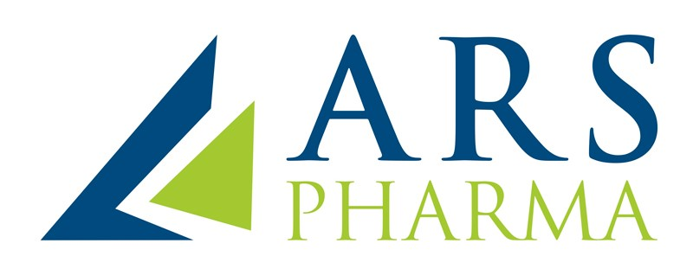

ARS Pharmaceuticals Reports Third Quarter 2025 Financial Results and Highlights for neffy® (epinephrine nasal spray)
$32.5 million in revenue, including $31.3 million in neffy U.S. net product revenue in third quarter of 2025
Continued U.S. product growth driven by direct-to-consumer (DTC) investments and real-world evidence, expected to accelerate with seamless prescribing experience
Strong balance sheet of $288.2 million cash, cash equivalents and short-term investments anticipated to fund operations through cash-flow break-even

Conference call to be held today, November 10, 2025, at 5:30 a.m. PT / 8:30 a.m. ET
SAN DIEGO, November 10, 2025– ARS Pharmaceuticals, Inc. (Nasdaq: SPRY), a biopharmaceutical company dedicated to empowering at-risk patients and their caregivers to better protect patients from allergic reactions that could lead to anaphylaxis, today announced financial results for the third quarter of 2025, and provided an update on the commercial launch of neffy® (epinephrine nasal spray), the first and only FDA- and European Commission-approved needle-free epinephrine treatment for Type I allergic reactions, including anaphylaxis.
“We are executing our commercial strategy across multiple fronts, with each element reinforcing the others to drive momentum,” said Richard Lowenthal, Co-Founder, President and CEO of ARS Pharma. “Our direct-to-consumer campaigns are generating measurable increases in patient awareness; real-world evidence data are further strengthening prescriber confidence in neffy’s effectiveness; and we are implementing advertising programs such as a free virtual prescriber option and zero dollar co-pay to further reduce barriers for patients, so that when healthcare providers want their patients to have neffy, we are able to assist and address potential obstacles.”



Third Quarter 2025 Financial Results
•
Revenue: Total revenue for the third quarter of 2025 was $32.5 million, comprised of $31.3 million in net product revenue from neffy sales in the U.S., and $1.1 million in supply revenue from partners. The cash value of royalties received from ALK-Abelló A/S (ALK) related to the launch of EURneffy® in Germany at the end of June 2025 was $0.1 million, which was recorded to the financing liability on the company’s balance sheet.
•
Research and Development (R&D) Expenses: R&D expenses for the third quarter of 2025 were $2.8 million, which was primarily associated with the ongoing Phase 2b clinical trial in urticaria and the ongoing post-marketing registry study for the treatment of anaphylaxis in oral food challenge or allergen immunotherapy clinics and other development expenses for neffy.
•
Selling, General and Administrative (SG&A) Expenses: SG&A expenses for the third quarter of 2025 were $74.8 million, reflecting the company’s substantial investment in the national DTC marketing campaign and continued sales and marketing expenses associated with the U.S. commercialization of neffy. The company remains committed to continued investment in neffy promotion to further expand patient and physician awareness and to accelerate market share growth.
•
Net Loss: Net loss for the third quarter of 2025 was $51.2 million, or $0.52 per share.
•
Cash Runway: As of September 30, 2025, ARS Pharma had cash, cash equivalents, and short-term investments of $288.2 million, with 98,844,178 shares of common stock outstanding. This includes the $100 million draw down from the company’s new $250 million senior security term loan facility with an affiliate of RA Capital Management, the company’s largest shareholder, and an affiliate of OMERS Life Sciences as lenders. The $100 million draw is intended to fund investment in the commercial growth of neffy, and support our marketing and medical affairs initiatives to generate and disseminate real-world evidence about neffy’s effectiveness. The company believes that its quarter-end cash position will fund operations through expected cash-flow breakeven.
neffy Commercial Launch Progress in the United States
•
DTC campaign growing awareness: The DTC campaign has significantly increased consumer awareness of neffy since its launch late in the second quarter of 2025, growing from a baseline consumer awareness of approximately 20% pre-campaign to 56% as of September 2025.
•
Gross-to-net retention of at least 50%: Unrestricted payor access is expected to be achieved while maintaining steady-state gross-to-net retention guidance of at least 50% including co-pay support programs, where it is anticipated to remain long-term.

Additional highlights from the neffy U.S. commercial launch include:
•
Increasing breadth and depth of healthcare provider (HCP) adoption: Over 18,000 HCPs have prescribed neffy to date, representing an 86% increase from August 2025.
•
“Get neffy on Us” campaign launched: The company initiated a new integrated commercial program to eliminate the time burden of an office visit and reduce cost barriers by giving patients with a current epinephrine autoinjector prescription or diagnosis the opportunity to switch to neffy via a free virtual provider at a $0 co-pay. Consumer surveys indicate that more than 70% of Type I allergy patients are open to using a virtual prescribing option.
•
Allergist real-world experience supports similar treatment outcomes as injection: An updated analysis of real-world treatment outcomes with 680 patients was presented as an oral late-breaker at the American College of Asthma, Allergy and Immunology (ACAAI) in early November 2025. The data showed about 90% of patients experiencing anaphylaxis were effectively treated with a single dose of neffy, and that this real-world effectiveness of neffy is indistinguishable from historically reported epinephrine injection. The neffy Experience Program provides 2 mg and 1 mg neffy to allergists for in-office use during an anaphylaxis event occurring during oral food challenges or allergen immunotherapy.
•
School access expansion: More than 6,500 schools have opted into the neffyinSchools program, each receiving two cartons (four single-use doses) of neffy 2 mg or 1 mg at no cost for emergency use through the School Health Corp. SHConnect platform.
•
U.S. registry study ongoing: The ARS Pharma post-marketing, registry-based randomized, controlled study of neffy for the treatment of anaphylaxis in oral food challenge or allergen immunotherapy clinics in the U.S. is ongoing.

Global Expansion for neffy and EURneffy
•
neffy approval in Japan: In September 2025, the Pharmaceutical and Medical Devices Agency (PMDA) granted approval for neffy 2 mg and 1 mg in Japan for the emergency treatment of allergic reactions (anaphylaxis) in adults and children who weigh greater than 15 kg. Alfresa owns the rights to market neffy in Japan and expects neffy to be available in the fourth quarter of 2025. Under the terms of the agreement, following listing of neffy on the Japanese National Health Institute (NHI) Drug Price List, ARS Pharma is eligible to receive a final regulatory milestone payment of $2 million, and to sell neffy to Alfresa at a transfer price.
•
EURneffy® launch in United Kingdom (U.K.): ALK successfully launched EURneffy® 2 mg in the U.K. in October 2025. The United Kingdom is the largest market outside of the United States for adrenaline (epinephrine) auto-injector sales.
•
EURneffy® 1 mg under review by EMA: EURneffy® 1 mg for children weighing 15 to < 30 kg is currently undergoing regulatory review by the European Medicines Agency (EMA), with approval anticipated in the first half of 2026.
•
Additional regulatory approvals anticipated: Regulatory approvals for neffy in Canada (with ALK-Abelló) is expected in the first quarter of 2026, with launch expected to start in the first half of 2026. Regulatory approval for neffy in China (in partnership with Pediatrix) is expected in the first half of 2026.
Clinical Expansion of Intranasal Epinephrine Program
•
Phase 2b trial in urticaria ongoing: A Phase 2b trial (NCT06927999) to evaluate intranasal epinephrine technology as a treatment for acute flares is enrolling patients with chronic spontaneous urticaria in the U.S. and Europe, with topline data anticipated in mid-2026.
Conference Call and Webcast Information
ARS Pharma management will host a conference call and webcast at 5:30 a.m. PT / 8:30 a.m. ET today, November 10, 2025. To access the webcast and slides, please visit the Events & Presentations page in the Investors & Media section of the Company’s website. A replay of the webcast will be available for 30 days following the event. Dial-in information for conference participants may be obtained by registering for the event.

EURneffy® is the trade name for neffy® (epinephrine nasal spray) in Europe.
About neffy®
neffy is a nasal spray used for emergency treatment of allergic reactions including anaphylaxis, in adults and children aged 4 years and older who weigh 33 lbs. or greater.
INDICATION AND IMPORTANT SAFETY INFORMATION FOR neffy (epinephrine nasal spray)
INDICATION
neffy is indicated for emergency treatment of type I allergic reactions, including anaphylaxis, in adult and pediatric patients aged 4 years and older who weigh 33 lbs. or greater.

IMPORTANT SAFETY INFORMATION
neffy contains epinephrine, a medicine used to treat allergic emergencies (anaphylaxis). Anaphylaxis can be life-threatening, can happen in minutes, and can be caused by stinging and biting insects, allergy injections, foods, medicines, exercise, or other unknown causes.
Always carry two neffy nasal sprays with you because you may not know when anaphylaxis may happen and because you may need a second dose of neffy if symptoms continue or come back. Each neffy contains a single dose of epinephrine. neffy is for use in the nose only.
Use neffy right away, as soon as you notice symptoms of an allergic reaction. If symptoms continue or get worse after the first dose of neffy, a second dose is needed. If needed, administer a second dose using a new neffy in the same nostril starting 5 minutes after the first dose. Get emergency medical help for further treatment of the allergic emergency (anaphylaxis), if needed after using neffy.
Tell your healthcare provider if you have underlying structural or anatomical nasal conditions, about all the medicines you take, and about all your medical conditions, especially if you have heart problems, kidney problems, low potassium in your blood, Parkinson’s disease, thyroid problems, high blood pressure, diabetes, are pregnant or plan to become pregnant, or plan to breastfeed.
Tell your healthcare provider if you take or use other nasal sprays or water pills (diuretics) or if you take medicines to treat depression, abnormal heart beats, Parkinson’s disease, heart disease, thyroid disease, medicines used in labor, and medicines to treat allergies. neffy and other medications may affect each other, causing side effects. neffy may affect the way other medicines work, and other medicines may affect how neffy works.
neffy may cause serious side effects. If you have certain medical conditions or take certain medicines, your condition may get worse, or you may have more or longer lasting side effects when you use neffy.

Common side effects of neffy include: nasal discomfort, headache, throat irritation, chest and nasal congestion, feeling overly excited, nervous or anxious, nose bleed, nose pain, sneezing, runny nose, dry nose or throat, tingling sensation, including in the nose, feeling tired, dizziness, nausea, and vomiting.
Tell your healthcare provider if you have any side effects that bother you or that do not go away after using neffy.
These are not all of the possible side effects of neffy. Call your healthcare provider for medical advice about side effects. To report side effects, contact ARS Pharmaceuticals Operations, Inc. at 1-877-MY-NEFFY (877-696-3339) or the FDA at 1-800-FDA-1088 or www.fda.gov/medwatch.
Please see the full Prescribing Information and Patient Information for neffy.

About Type I Allergic Reactions Including Anaphylaxis
Type I allergic reactions are serious and potentially life-threatening events that can occur within minutes of exposure to an allergen and require immediate treatment with epinephrine, the only FDA-approved medication for these reactions. While epinephrine auto-injectors have been shown to be highly effective, there are well published limitations that result in many patients and caregivers delaying or not administering treatment in an emergency situation. These limitations include fear of the needle, lack of portability, needle-related safety concerns, lack of reliability, and complexity of the devices. There are approximately 40 million people in the United States who experience Type I allergic reactions. Of this group, over the last three years, approximately 20 million people have been diagnosed and treated for severe Type I allergic reactions that may lead to anaphylaxis, but (in 2023, for example) only 3.2 million filled their active epinephrine auto-injector prescription, and of those, only half consistently carry their prescribed auto-injector. Even if patients or caregivers carry an auto-injector, more than half either delay or do not administer the device when needed in an emergency.
About ARS Pharmaceuticals, Inc.
ARS Pharma is a biopharmaceutical company dedicated to empowering at-risk patients and their caregivers to better protect patients from allergic reactions that could lead to anaphylaxis. The Company is commercializing neffy® (trade name EURneffy® in the EU), an epinephrine nasal spray indicated in the U.S. for emergency treatment of Type I allergic reactions, including anaphylaxis, in adult patients and pediatric patients 4 years of age and older who weigh 33 lbs. or greater, and in the EU for emergency treatment of allergic reactions (anaphylaxis) due to insect stings or bites, foods, medicinal products, and other allergens as well as idiopathic or exercise induced anaphylaxis in adults and children who weigh 30 kg or greater. For more information, visit www.ars-pharma.com.

Forward-Looking Statements
Statements in this press release that are not purely historical in nature are “forward-looking statements” within the meaning of the Private Securities Litigation Reform Act of 1995. These statements include, but are not limited to: evaluations, judgments, and expectations regarding ARS Pharma’s marketing and commercialization strategies; the anticipated use of proceeds from the loan facility; ARS Pharma’s guidance that its financial position is expected to support its operating plans through expected cash-flow breakeven; expectations regarding the HCP prescribing experience; the projection that ARS Pharma will achieve unrestricted payor access while maintaining a steady-state gross-to-net retention of at least 50% for the long-term; the anticipated timing of regulatory decisions for neffy in Canada and China and the expected timing of commercial launches in Canada, China, and Japan; the anticipated timing of the EMA’s regulatory decisions for EURneffy 1 mg; the potential to achieve regulatory milestone payments and the timing of payment thereof; the anticipated timing for topline data from the urticaria trial and the potential for ARS Pharma’s intranasal epinephrine technology to expand into the urticaria indication; and other statements that are not historical fact. Because such statements are subject to risks and uncertainties, actual results may differ materially from those expressed or implied by such forward-looking statements. Words such as “anticipate,” “believe,” “can,” “could,” “expect,” “if,” “may,” “potential,” “plan,” “will,” and similar expressions are intended to identify forward-looking statements. These forward-looking statements are based upon ARS Pharma’s current expectations and involve assumptions that may never materialize or may prove to be incorrect.
Actual results and the timing of events could differ materially from those anticipated in such forward-looking statements as a result of various risks and uncertainties, which include, without limitation: potential safety and other complications from neffy; the ability to maintain regulatory approval for neffy in its currently approved indications; the scope, progress and expansion of developing and commercializing neffy; the risk that ARS Pharma may not realize its expected return on investment from its DTC campaign; the scope, progress and expansion of developing our intranasal epinephrine technology; clinical trial results; the potential for governments and payors to delay, limit or deny coverage for neffy; the size and growth of the market for neffy and the rate and degree of market acceptance thereof vis-à-vis intramuscular injectable products; ARS Pharma’s ability to protect its intellectual property position; and the impact of government laws, regulations and policies. Additional risks and uncertainties that could cause actual outcomes and results to differ materially from those contemplated by the forward-looking statements are included under the caption “Risk Factors” in ARS Pharma’s Quarterly Report on Form 10-Q for the quarter ended June 30, 2025, filed with the Securities and Exchange Commission (“SEC”) on August 13, 2025 and in ARS Pharma’s Quarterly Report on Form 10-Q for the quarter ended September 30, 2025, to be filed with the SEC today. These documents can also be accessed on ARS Pharma’s website at www.ars-pharma.com by clicking on the link “Financials & Filings” under the “Investors & Media” tab.
The forward-looking statements included in this press release are made only as of the date hereof. ARS Pharma assumes no obligation and does not intend to update these forward-looking statements, except as required by law. For more information, visit www.ars-pharma.com, and follow us on LinkedIn and X.

Investor Contact:
Justin Chakma, ARS Pharma
justinc@ars-pharma.com

Media Contact:
Christy Curran, Sam Brown Inc.
christycurran@sambrown.com
615.414.8668

ARS Pharmaceuticals, Inc.
Condensed Consolidated Balance Sheets
(in thousands, except share and par value data)
 |  | September 30, 2025 |  |  |  | December 31, 2024
 |  | (unaudited)
Assets
Current assets:
Cash and cash equivalents |  | $ | 59,557 |  |  | $ | 50,817
Short-term investments |  |  | 228,652 |  |  |  | 263,205
Accounts receivable, net |  |  | 36,451 |  |  |  | 8,175
Inventories |  |  | 7,782 |  |  |  | 5,212
Prepaid expenses and other current assets |  |  | 6,421 |  |  |  | 6,886
Total current assets |  |  | 338,863 |  |  |  | 334,295
Long-term inventories |  |  | 13,645 |  |  |  | 5,307
Right-of-use asset |  |  | 1,439 |  |  |  | 37
Fixed assets, net |  |  | 1,209 |  |  |  | 1,029
Intangible assets, net |  |  | 14,729 |  |  |  | 7,371
Other assets |  |  | 2,918 |  |  |  | 3,114
Total assets |  | $ | 372,803 |  |  | $ | 351,153
Liabilities and stockholders’ equity
Current liabilities:
Accounts payable and accrued liabilities (including related party amounts of $4,269 and $656, respectively) |  | $ | 49,768 |  |  | $ | 22,841
Contract liability, current |  |  | 526 |  |  |  | 557
Lease liability, current |  |  | 583 |  |  |  | 42
Total current liabilities |  |  | 50,877 |  |  |  | 23,440
Term loans, net (including related party amounts of $4,811 and $0, respectively) |  |  | 96,229 |  |  |  | —
Financing liability |  |  | 72,044 |  |  |  | 69,383
Contract liability, net of current portion |  |  | 1,268 |  |  |  | 1,532
Lease liability, net of current portion |  |  | 949 |  |  |  | —
Other accrued liabilities |  |  | 3,781 |  |  |  | —
Total liabilities |  |  | 225,148 |  |  |  | 94,355
Commitments and contingencies
Stockholders’ equity
Preferred stock, $0.0001 par value per share; 10,000,000 shares authorized at September 30, 2025 and December 31, 2024; no shares issued and outstanding at September 30, 2025 and December 31, 2024 |  |  | — |  |  |  | —
Common stock, $0.0001 par value per share; 200,000,000 shares authorized at September 30, 2025 and December 31, 2024; 98,844,178 and 97,954,172 shares issued and outstanding at September 30, 2025 and December 31, 2024, respectively |  |  | 10 |  |  |  | 10
Additional paid-in capital |  |  | 400,931 |  |  |  | 379,873
Accumulated other comprehensive (loss) gain, net |  |  | (7 | ) |  |  | 220
Accumulated deficit |  |  | (253,279 | ) |  |  | (123,305 | )
Total stockholders’ equity |  |  | 147,655 |  |  |  | 256,798
Total liabilities and stockholders’ equity |  | $ | 372,803 |  |  | $ | 351,153

ARS Pharmaceuticals, Inc.
Condensed Consolidated Statements of Operations and Comprehensive Loss
(in thousands, except share and per share data)
(unaudited)
 |  | Three Months Ended September 30, |  |  |  |  |  |  |  | Nine Months Ended September 30,
 |  | 2025 |  |  |  | 2024 |  |  |  | 2025 |  |  |  | 2024
Revenue:
Product revenue, net |  | $ | 31,300 |  |  | $ | 568 |  |  | $ | 51,863 |  |  | $ | 568
Revenue under collaboration agreements |  |  | 55 |  |  |  | 1,500 |  |  |  | 2,859 |  |  |  | 2,000
Revenue under supply agreements |  |  | 1,146 |  |  |  | — |  |  |  | 1,469 |  |  |  | —
Total revenue |  |  | 32,501 |  |  |  | 2,068 |  |  |  | 56,191 |  |  |  | 2,568
Operating expenses:
Cost of goods sold (including related party amounts of $2,046, $0, $3,400, and $0, respectively) |  |  | 8,191 |  |  |  | 112 |  |  |  | 14,269 |  |  |  | 112
Research and development (including related party amounts of $559, $406, $1,804, and $1,651, respectively) |  |  | 2,751 |  |  |  | 4,423 |  |  |  | 9,738 |  |  |  | 16,553
Selling, general and administrative (including related party amounts of $123, $129, $354, and $337, respectively) |  |  | 74,751 |  |  |  | 19,281 |  |  |  | 170,167 |  |  |  | 36,183
Total operating expenses |  |  | 85,693 |  |  |  | 23,816 |  |  |  | 194,174 |  |  |  | 52,848
Loss from operations |  |  | (53,192 | ) |  |  | (21,748 | ) |  |  | (137,983 | ) |  |  | (50,280 | )
Other income (expense), net (including related party amounts of $(3), $0, $(3), and $0, respectively) |  |  | 2,041 |  |  |  | 2,620 |  |  |  | 8,009 |  |  |  | 8,344
Net loss |  | $ | (51,151 | ) |  | $ | (19,128 | ) |  | $ | (129,974 | ) |  | $ | (41,936 | )
Change in unrealized gains and losses on available-for-sale securities |  |  | 39 |  |  |  | 484 |  |  |  | (227 | ) |  |  | 290
Comprehensive loss |  | $ | (51,112 | ) |  | $ | (18,644 | ) |  | $ | (130,201 | ) |  | $ | (41,646 | )
Net loss per share, basic and diluted |  | $ | (0.52 | ) |  | $ | (0.20 | ) |  | $ | (1.32 | ) |  | $ | (0.43 | )
Weighted-average shares outstanding used in computing net loss per share, basic and diluted |  |  | 98,807,600 |  |  |  | 97,032,331 |  |  |  | 98,412,739 |  |  |  | 96,782,818

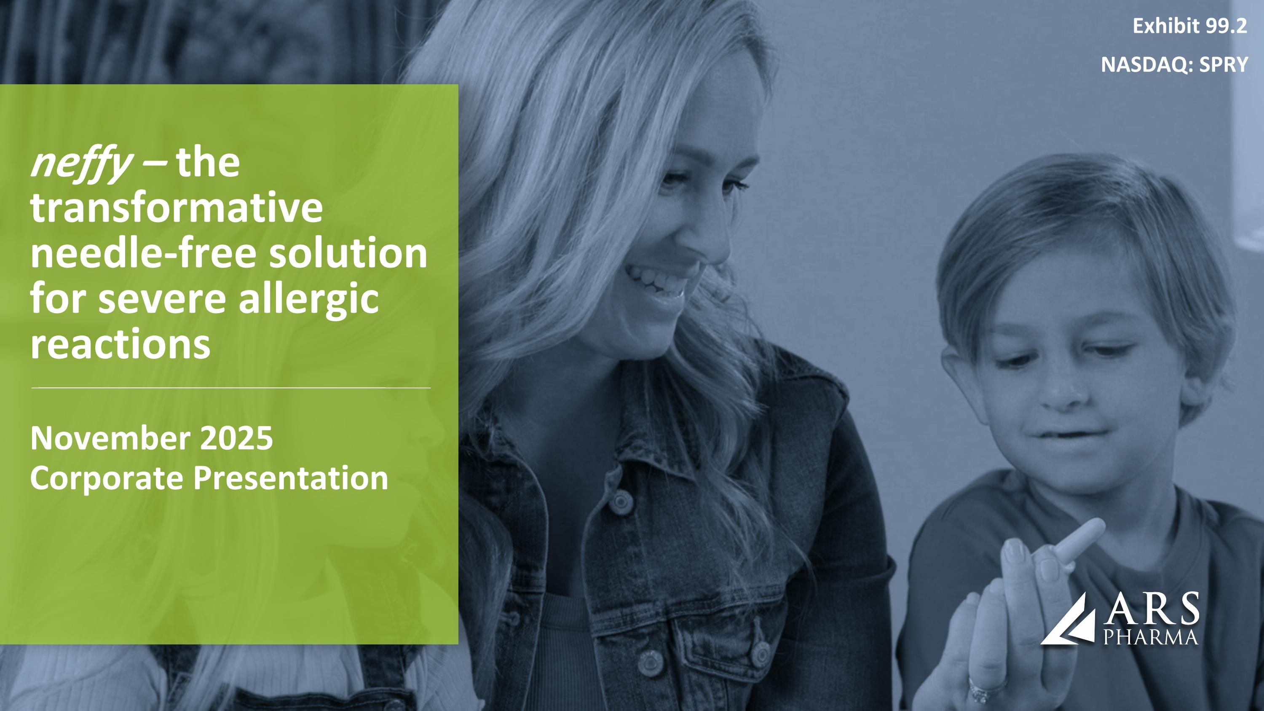
November 2025 Corporate Presentation neffy – the transformative needle-free solution for severe allergic reactions Exhibit 99.2 NASDAQ: SPRY

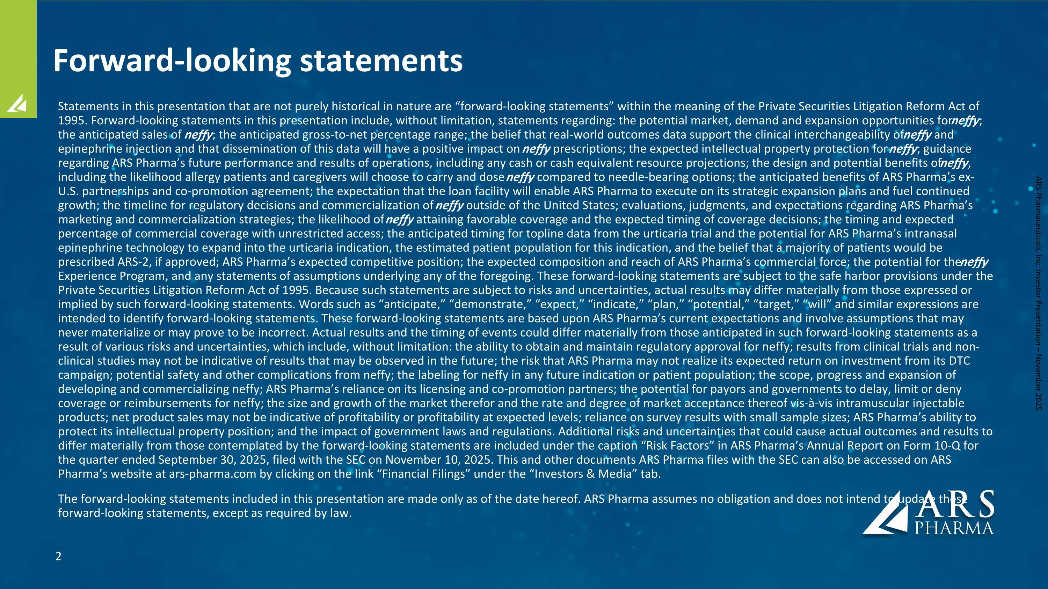
Forward-looking statements Statements in this presentation that are not purely historical in nature are “forward-looking statements” within the meaning of the Private Securities Litigation Reform Act of 1995. Forward-looking statements in this presentation include, without limitation, statements regarding: the potential market, demand and expansion opportunities for neffy; the anticipated sales of neffy; the anticipated gross-to-net percentage range; the belief that real-world outcomes data support the clinical interchangeability of neffy and epinephrine injection and that dissemination of this data will have a positive impact on neffy prescriptions; the expected intellectual property protection for neffy; guidance regarding ARS Pharma’s future performance and results of operations, including any cash or cash equivalent resource projections; the design and potential benefits of neffy, including the likelihood allergy patients and caregivers will choose to carry and dose neffy compared to needle-bearing options; the anticipated benefits of ARS Pharma’s ex-U.S. partnerships and co-promotion agreement; the expectation that the loan facility will enable ARS Pharma to execute on its strategic expansion plans and fuel continued growth; the timeline for regulatory decisions and commercialization of neffy outside of the United States; evaluations, judgments, and expectations regarding ARS Pharma’s marketing and commercialization strategies; the likelihood of neffy attaining favorable coverage and the expected timing of coverage decisions; the timing and expected percentage of commercial coverage with unrestricted access; the anticipated timing for topline data from the urticaria trial and the potential for ARS Pharma’s intranasal epinephrine technology to expand into the urticaria indication, the estimated patient population for this indication, and the belief that a majority of patients would be prescribed ARS-2, if approved; ARS Pharma’s expected competitive position; the expected composition and reach of ARS Pharma’s commercial force; the potential for the neffy Experience Program, and any statements of assumptions underlying any of the foregoing. These forward-looking statements are subject to the safe harbor provisions under the Private Securities Litigation Reform Act of 1995. Because such statements are subject to risks and uncertainties, actual results may differ materially from those expressed or implied by such forward-looking statements. Words such as “anticipate,” “demonstrate,” “expect,” “indicate,” “plan,” “potential,” “target,” “will” and similar expressions are intended to identify forward-looking statements. These forward-looking statements are based upon ARS Pharma’s current expectations and involve assumptions that may never materialize or may prove to be incorrect. Actual results and the timing of events could differ materially from those anticipated in such forward-looking statements as a result of various risks and uncertainties, which include, without limitation: the ability to obtain and maintain regulatory approval for neffy; results from clinical trials and non-clinical studies may not be indicative of results that may be observed in the future; the risk that ARS Pharma may not realize its expected return on investment from its DTC campaign; potential safety and other complications from neffy; the labeling for neffy in any future indication or patient population; the scope, progress and expansion of developing and commercializing neffy; ARS Pharma’s reliance on its licensing and co-promotion partners; the potential for payors and governments to delay, limit or deny coverage or reimbursements for neffy; the size and growth of the market therefor and the rate and degree of market acceptance thereof vis-à-vis intramuscular injectable products; net product sales may not be indicative of profitability or profitability at expected levels; reliance on survey results with small sample sizes; ARS Pharma’s ability to protect its intellectual property position; and the impact of government laws and regulations. Additional risks and uncertainties that could cause actual outcomes and results to differ materially from those contemplated by the forward-looking statements are included under the caption “Risk Factors” in ARS Pharma’s Annual Report on Form 10-Q for the quarter ended September 30, 2025, filed with the SEC on November 10, 2025. This and other documents ARS Pharma files with the SEC can also be accessed on ARS Pharma’s website at ars-pharma.com by clicking on the link “Financial Filings” under the “Investors & Media” tab. The forward-looking statements included in this presentation are made only as of the date hereof. ARS Pharma assumes no obligation and does not intend to update these forward-looking statements, except as required by law. ARS Pharmaceuticals, Inc. Investor Presentation – November 2025

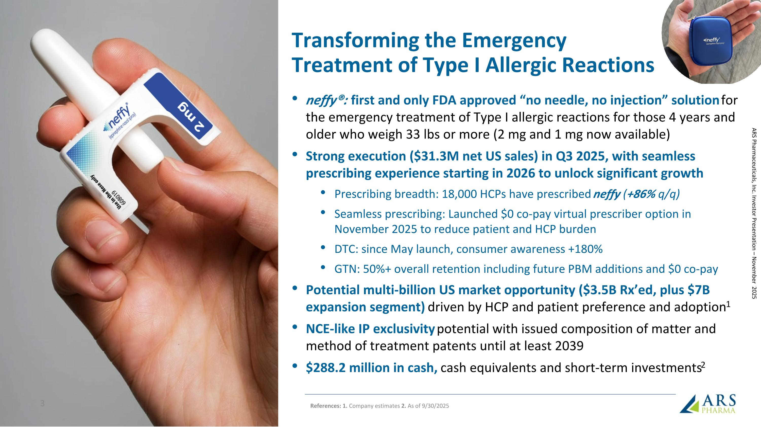
Transforming the Emergency Treatment of Type I Allergic Reactions neffy®: first and only FDA approved “no needle, no injection” solution for the emergency treatment of Type I allergic reactions for those 4 years and older who weigh 33 lbs or more (2 mg and 1 mg now available) Strong execution ($31.3M net US sales) in Q3 2025, with seamless prescribing experience starting in 2026 to unlock significant growth Prescribing breadth: 18,000 HCPs have prescribed neffy (+86% q/q) Seamless prescribing: Launched $0 co-pay virtual prescriber option in November 2025 to reduce patient and HCP burden DTC: since May launch, consumer awareness +180% GTN: 50%+ overall retention including future PBM additions and $0 co-pay Potential multi-billion US market opportunity ($3.5B Rx’ed, plus $7B expansion segment) driven by HCP and patient preference and adoption1 NCE-like IP exclusivity potential with issued composition of matter and method of treatment patents until at least 2039 $288.2 million in cash, cash equivalents and short-term investments2 ARS Pharmaceuticals, Inc. Investor Presentation – November 2025 References: 1. Company estimates 2. As of 9/30/2025

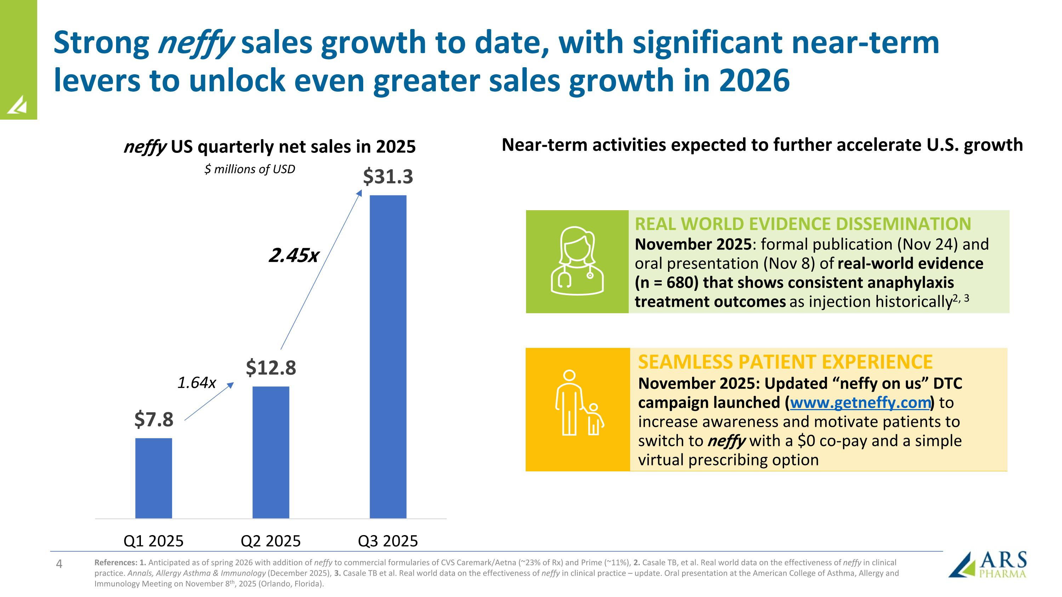
Strong neffy sales growth to date, with significant near-term levers to unlock even greater sales growth in 2026 neffy US quarterly net sales in 2025 $ millions of USD 1.64x 2.45x Near-term activities expected to further accelerate U.S. growth REAL WORLD EVIDENCE DISSEMINATION November 2025: formal publication (Nov 24) and oral presentation (Nov 8) of real-world evidence (n = 680) that shows consistent anaphylaxis treatment outcomes as injection historically2, 3 SEAMLESS PATIENT EXPERIENCE November 2025: Updated “neffy on us” DTC campaign launched (www.getneffy.com) to increase awareness and motivate patients to switch to neffy with a $0 co-pay and a simple virtual prescribing option References: 1. Anticipated as of spring 2026 with addition of neffy to commercial formularies of CVS Caremark/Aetna (~23% of Rx) and Prime (~11%), 2. Casale TB, et al. Real world data on the effectiveness of neffy in clinical practice. Annals, Allergy Asthma & Immunology (December 2025), 3. Casale TB et al. Real world data on the effectiveness of neffy in clinical practice – update. Oral presentation at the American College of Asthma, Allergy and Immunology Meeting on November 8th, 2025 (Orlando, Florida).

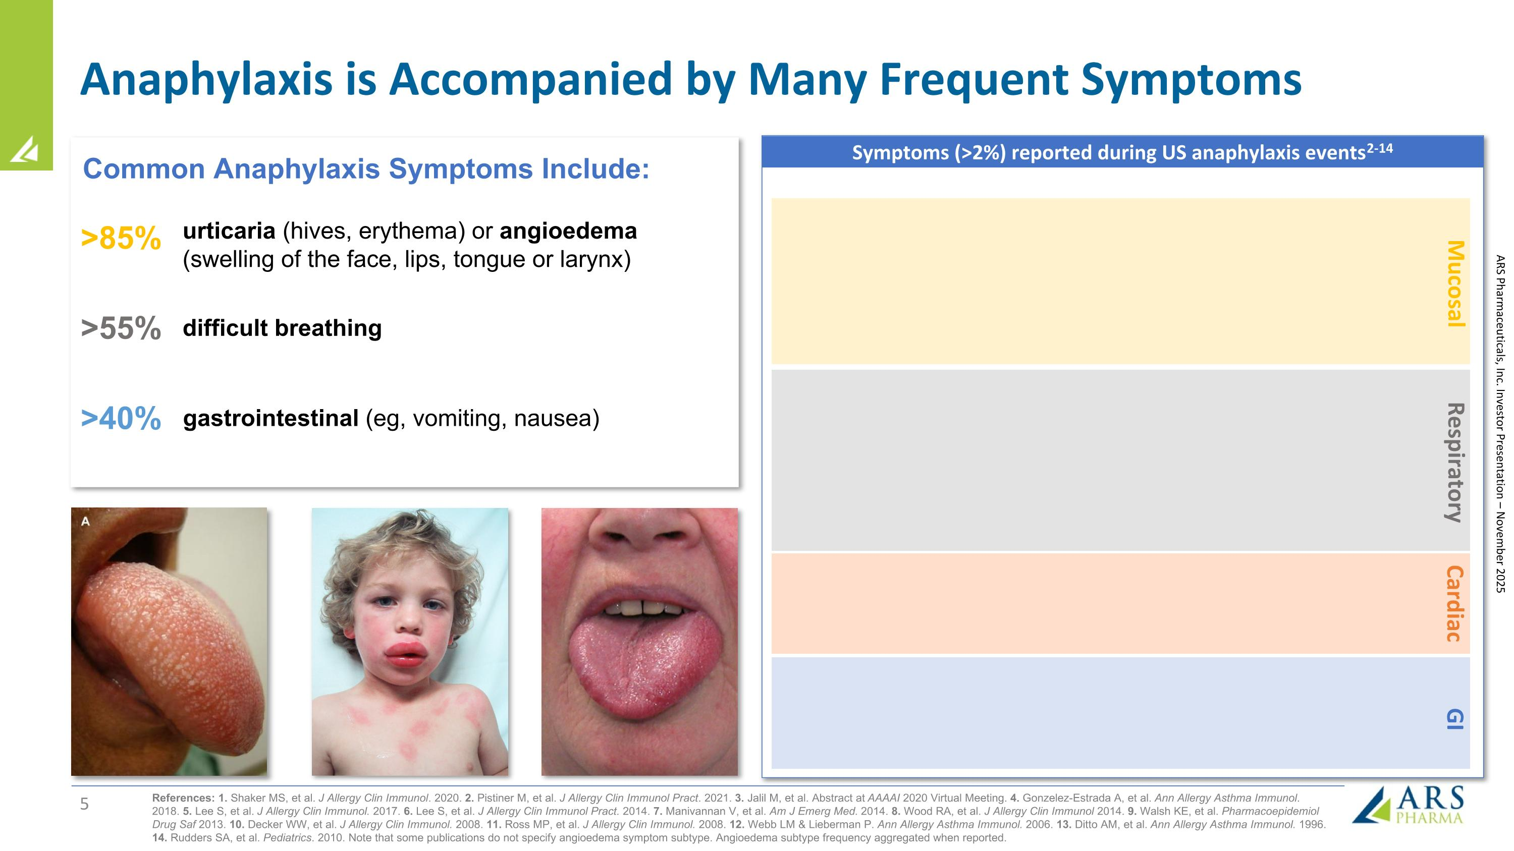
Anaphylaxis is Accompanied by Many Frequent Symptoms References: 1. Shaker MS, et al. J Allergy Clin Immunol. 2020. 2. Pistiner M, et al. J Allergy Clin Immunol Pract. 2021. 3. Jalil M, et al. Abstract at AAAAI 2020 Virtual Meeting. 4. Gonzelez-Estrada A, et al. Ann Allergy Asthma Immunol. 2018. 5. Lee S, et al. J Allergy Clin Immunol. 2017. 6. Lee S, et al. J Allergy Clin Immunol Pract. 2014. 7. Manivannan V, et al. Am J Emerg Med. 2014. 8. Wood RA, et al. J Allergy Clin Immunol 2014. 9. Walsh KE, et al. Pharmacoepidemiol Drug Saf 2013. 10. Decker WW, et al. J Allergy Clin Immunol. 2008. 11. Ross MP, et al. J Allergy Clin Immunol. 2008. 12. Webb LM & Lieberman P. Ann Allergy Asthma Immunol. 2006. 13. Ditto AM, et al. Ann Allergy Asthma Immunol. 1996. 14. Rudders SA, et al. Pediatrics. 2010. Note that some publications do not specify angioedema symptom subtype. Angioedema subtype frequency aggregated when reported. Symptoms (>2%) reported during US anaphylaxis events 2-14 Mucosal Respiratory Cardiac GI urticaria (hives, erythema) or angioedema (swelling of the face, lips, tongue or larynx) >85% >55% gastrointestinal (eg, vomiting, nausea) Common Anaphylaxis Symptoms Include: difficult breathing >40% ARS Pharmaceuticals, Inc. Investor Presentation – November 2025

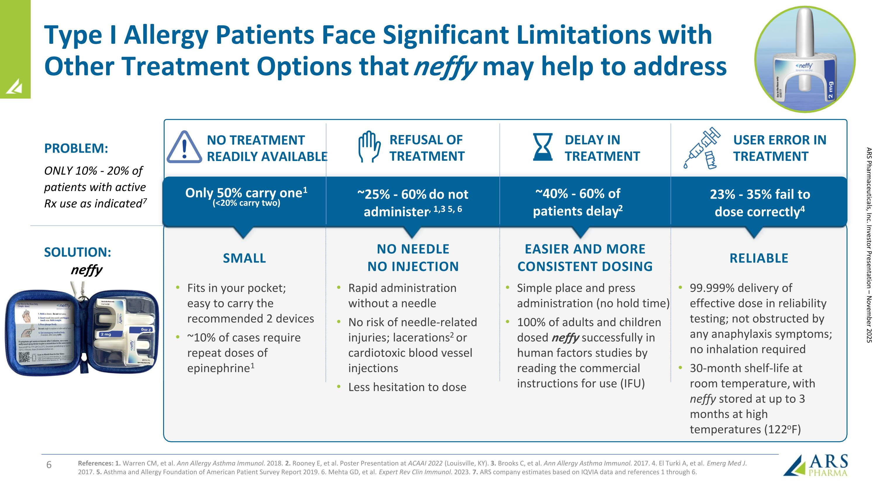
Type I Allergy Patients Face Significant Limitations with ?Other Treatment Options that neffy may help to address References: 1. Warren CM, et al. Ann Allergy Asthma Immunol. 2018. 2. Rooney E, et al. Poster Presentation at ACAAI 2022 (Louisville, KY). 3. Brooks C, et al. Ann Allergy Asthma Immunol. 2017. 4. El Turki A, et al. Emerg Med J. 2017. 5. Asthma and Allergy Foundation of American Patient Survey Report 2019. 6. Mehta GD, et al. Expert Rev Clin Immunol. 2023. 7. ARS company estimates based on IQVIA data and references 1 through 6. Rapid administration without a needle No risk of needle-related injuries; lacerations2 or cardiotoxic blood vessel injections Less hesitation to dose NO NEEDLE NO INJECTION Fits in your pocket; ?easy to carry the recommended 2 devices ~10% of cases require repeat doses of epinephrine1 EASIER AND MORE CONSISTENT DOSING Simple place and press administration (no hold time) 100% of adults and children dosed neffy successfully in human factors studies by reading the commercial instructions for use (IFU) RELIABLE 99.999% delivery of effective dose in reliability testing; not obstructed by any anaphylaxis symptoms; ?no inhalation required 30-month shelf-life at ?room temperature, with ?neffy stored at up to 3 months at high temperatures (122oF) Only 50% carry one1 (<20% carry two) ~25% - 60% do not administer, 1,3 5, 6 NO TREATMENT READILY AVAILABLE REFUSAL OF TREATMENT ~40% - 60% of patients delay2 DELAY IN TREATMENT 23% - 35% fail to ?dose correctly4 USER ERROR IN TREATMENT SOLUTION: neffy PROBLEM: ONLY 10% - 20% of patients with active Rx use as indicated7 SMALL ARS Pharmaceuticals, Inc. Investor Presentation – November 2025

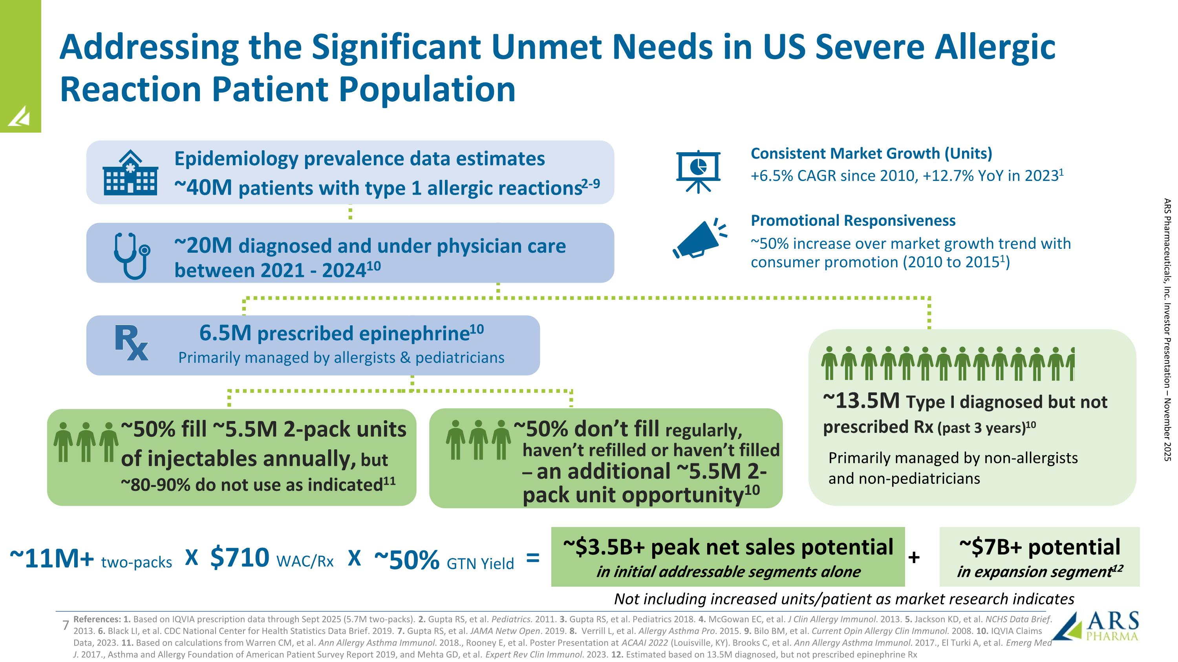
Addressing the Significant Unmet Needs in US Severe Allergic Reaction Patient Population References: 1. Based on IQVIA prescription data through Sept 2025 (5.7M two-packs). 2. Gupta RS, et al. Pediatrics. 2011. 3. Gupta RS, et al. Pediatrics 2018. 4. McGowan EC, et al. J Clin Allergy Immunol. 2013. 5. Jackson KD, et al. NCHS Data Brief. 2013. 6. Black LI, et al. CDC National Center for Health Statistics Data Brief. 2019. 7. Gupta RS, et al. JAMA Netw Open. 2019. 8. Verrill L, et al. Allergy Asthma Pro. 2015. 9. Bilo BM, et al. Current Opin Allergy Clin Immunol. 2008. 10. IQVIA Claims Data, 2023. 11. Based on calculations from Warren CM, et al. Ann Allergy Asthma Immunol. 2018., Rooney E, et al. Poster Presentation at ACAAI 2022 (Louisville, KY). Brooks C, et al. Ann Allergy Asthma Immunol. 2017., El Turki A, et al. Emerg Med J. 2017., Asthma and Allergy Foundation of American Patient Survey Report 2019, and Mehta GD, et al. Expert Rev Clin Immunol. 2023. 12. Estimated based on 13.5M diagnosed, but not prescribed epinephrine Rx Promotional Responsiveness ~20M diagnosed and under physician care between 2021 - 202410 Epidemiology prevalence data estimates ~40M patients with type 1 allergic reactions2-9 ~50% increase over market growth trend with consumer promotion (2010 to 20151) Consistent Market Growth (Units) +6.5% CAGR since 2010, +12.7% YoY in 20231 ~50% fill ~5.5M 2-pack units of injectables annually, but ~80-90% do not use as indicated11 ~13.5M Type I diagnosed but not prescribed Rx (past 3 years)10 ~50% don’t fill regularly, haven’t refilled or haven’t filled – an additional ~5.5M 2-pack unit opportunity10 6.5M prescribed epinephrine10 Primarily managed by allergists & pediatricians Primarily managed by non-allergists and non-pediatricians $710 WAC/Rx ~50% GTN Yield ~11M+ two-packs ~$3.5B+ peak net sales potential in initial addressable segments alone = X X ~$7B+ potential in expansion segment12 + ARS Pharmaceuticals, Inc. Investor Presentation – November 2025 Not including increased units/patient as market research indicates

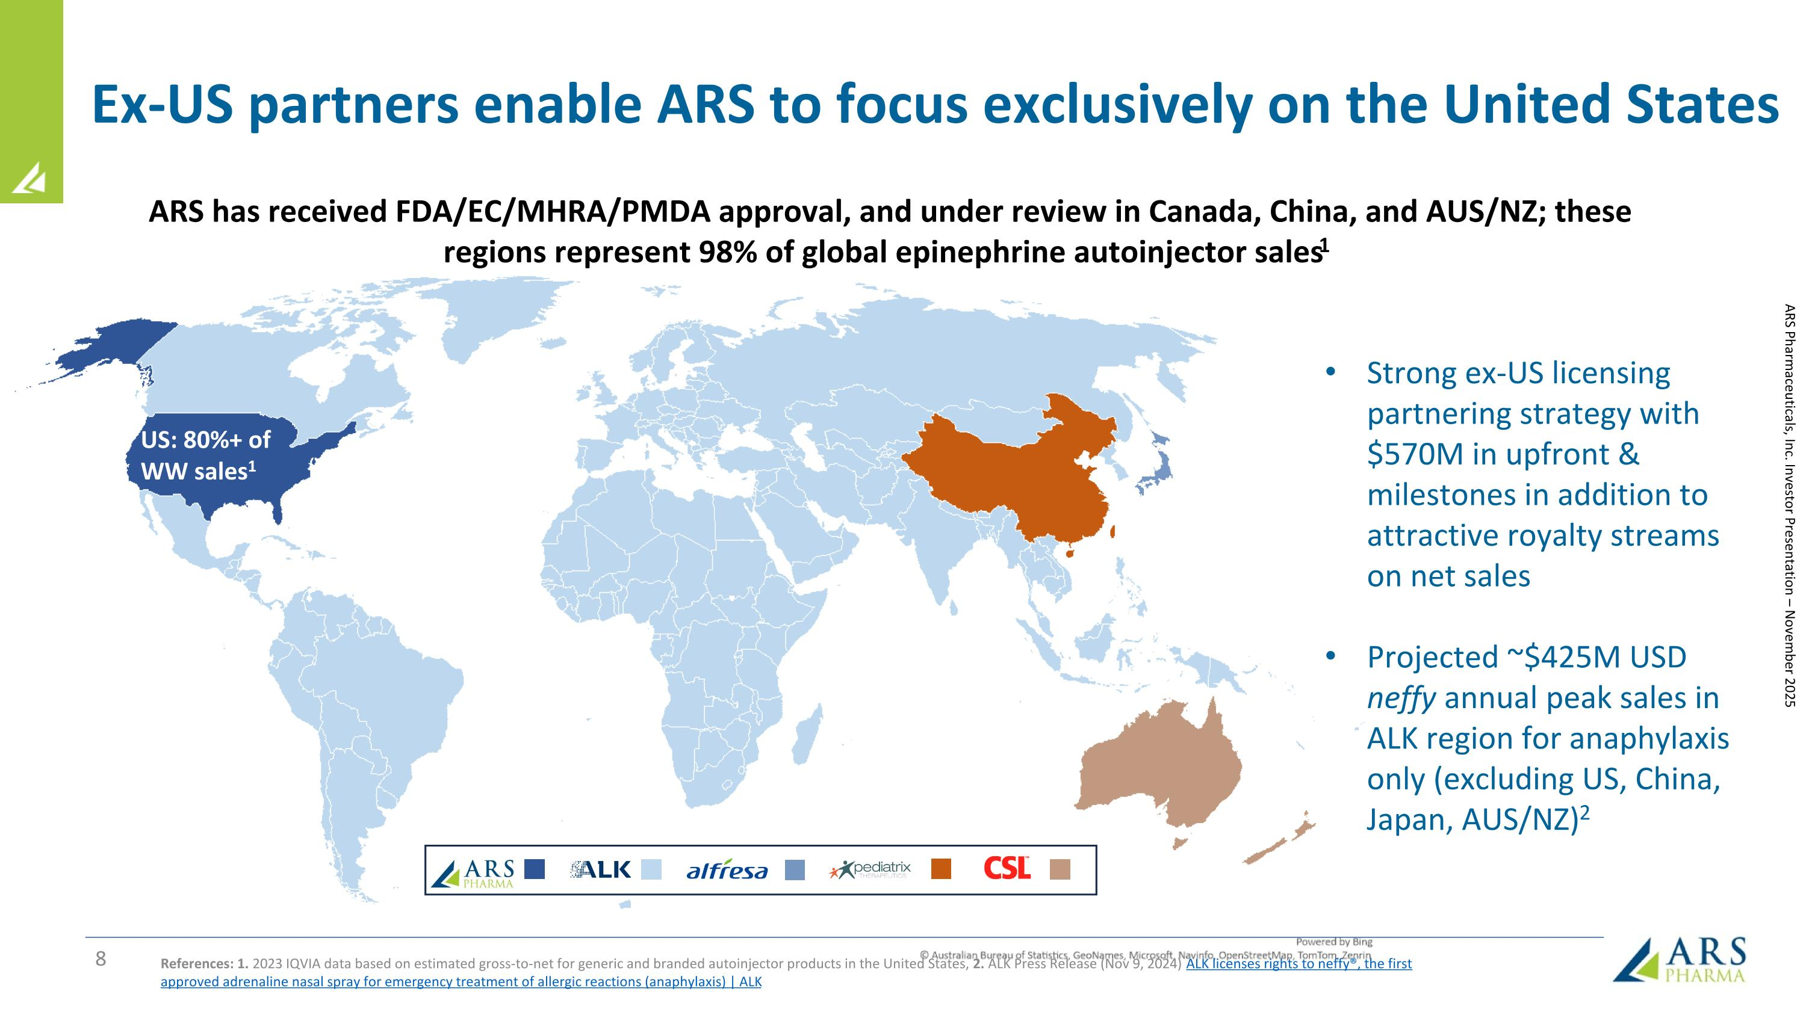
Ex-US partners enable ARS to focus exclusively on the United States References: 1. 2023 IQVIA data based on estimated gross-to-net for generic and branded autoinjector products in the United States, 2. ALK Press Release (Nov 9, 2024) ALK licenses rights to neffy®, the first approved adrenaline nasal spray for emergency treatment of allergic reactions (anaphylaxis) | ALK ARS Pharmaceuticals, Inc. Investor Presentation – November 2025 US: 80%+ of WW sales1 ARS has received FDA/EC/MHRA/PMDA approval, and under review in Canada, China, and AUS/NZ; these regions represent 98% of global epinephrine autoinjector sales1 Strong ex-US licensing partnering strategy with $570M in upfront & milestones in addition to attractive royalty streams on net sales Projected ~$425M USD neffy annual peak sales in ALK region for anaphylaxis only (excluding US, China, Japan, AUS/NZ)2

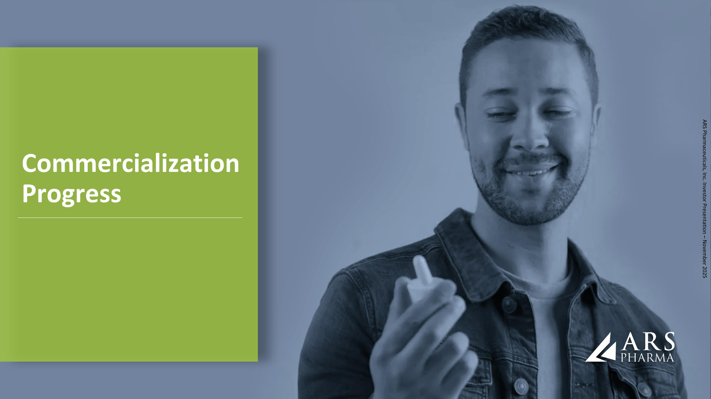
Commercialization Progress ARS Pharmaceuticals, Inc. Investor Presentation – November 2025

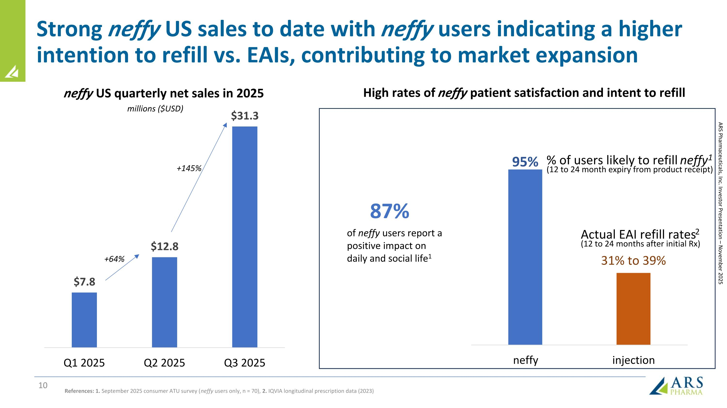
Strong neffy US sales to date with neffy users indicating a higher intention to refill vs. EAIs, contributing to market expansion % of users likely to refill neffy1 (12 to 24 month expiry from product receipt) Actual EAI refill rates2 (12 to 24 months after initial Rx) 87% of neffy users report a positive impact on daily and social life1 neffy US quarterly net sales in 2025 References: 1. September 2025 consumer ATU survey (neffy users only, n = 70), 2. IQVIA longitudinal prescription data (2023) millions ($USD) High rates of neffy patient satisfaction and intent to refill +64% +145% ARS Pharmaceuticals, Inc. Investor Presentation – November 2025

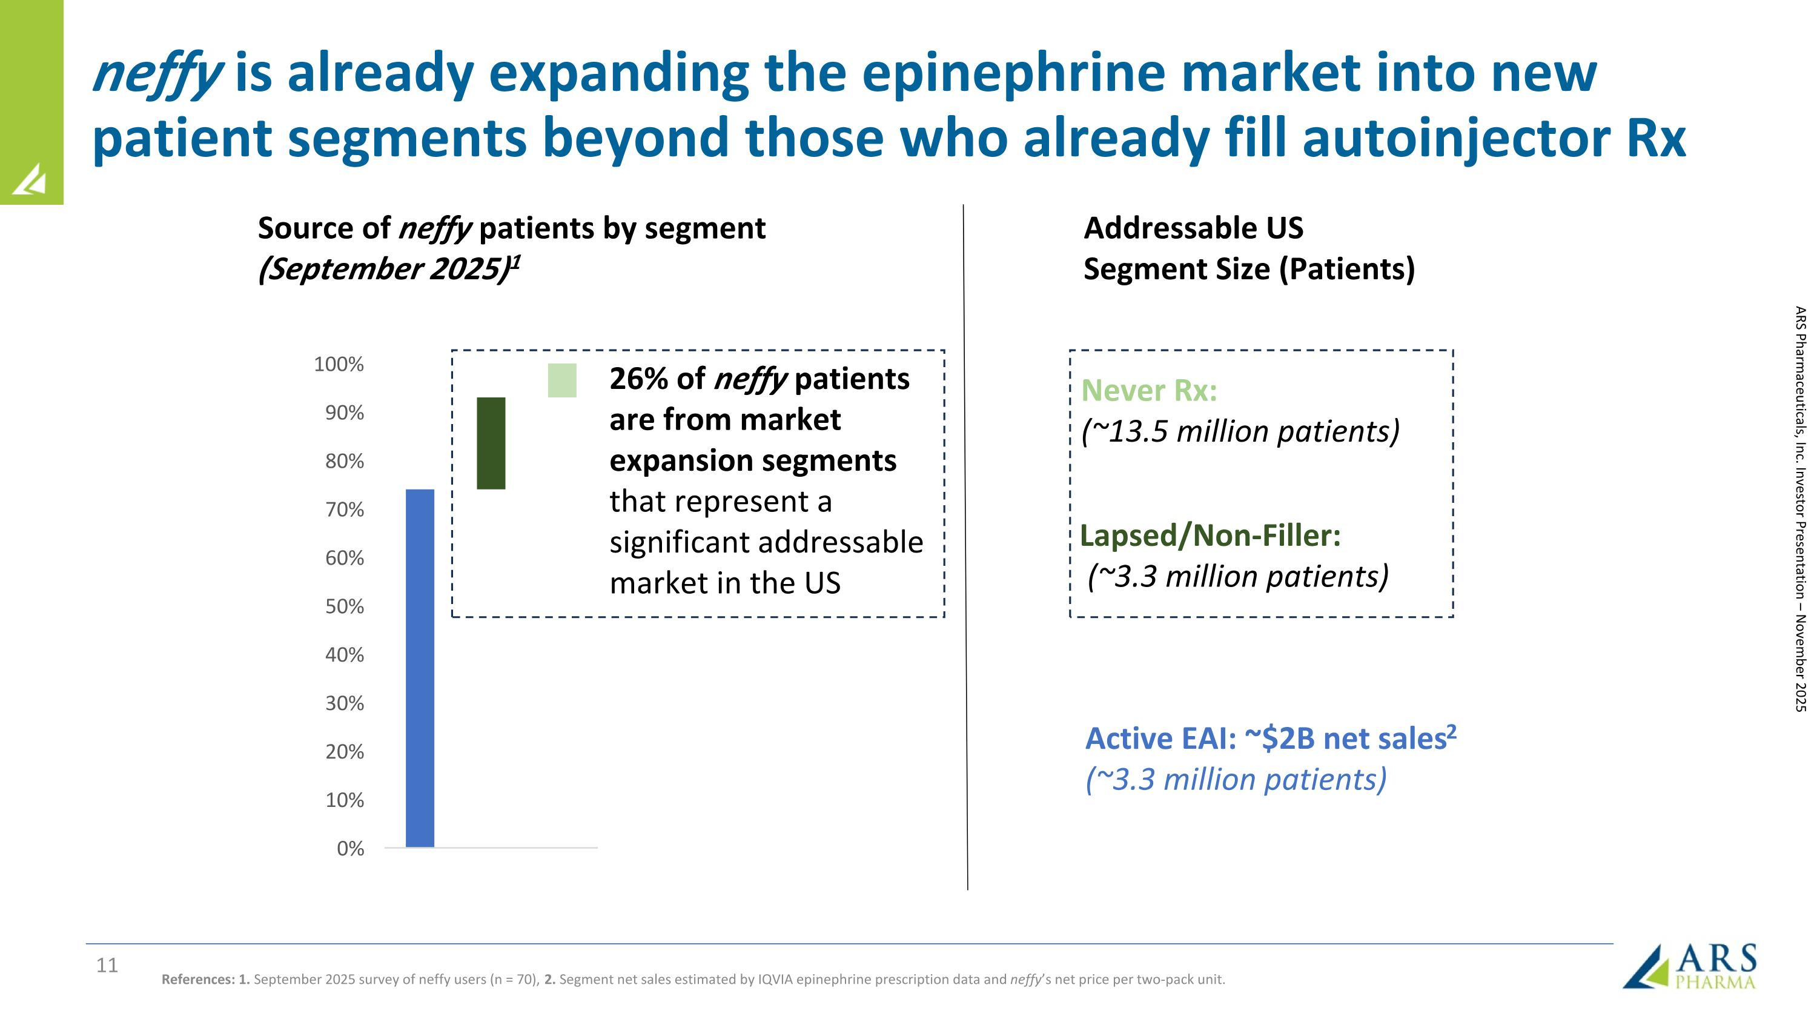
neffy is already expanding the epinephrine market into new patient segments beyond those who already fill autoinjector Rx Source of neffy patients by segment (September 2025)1 Active EAI: ~$2B net sales2 (~3.3 million patients) Addressable US Segment Size (Patients) References: 1. September 2025 survey of neffy users (n = 70), 2. Segment net sales estimated by IQVIA epinephrine prescription data and neffy’s net price per two-pack unit. ARS Pharmaceuticals, Inc. Investor Presentation – November 2025 26% of neffy patients are from market expansion segments that represent a significant addressable market in the US Lapsed/Non-Filler: (~3.3 million patients) Never Rx: (~13.5 million patients)

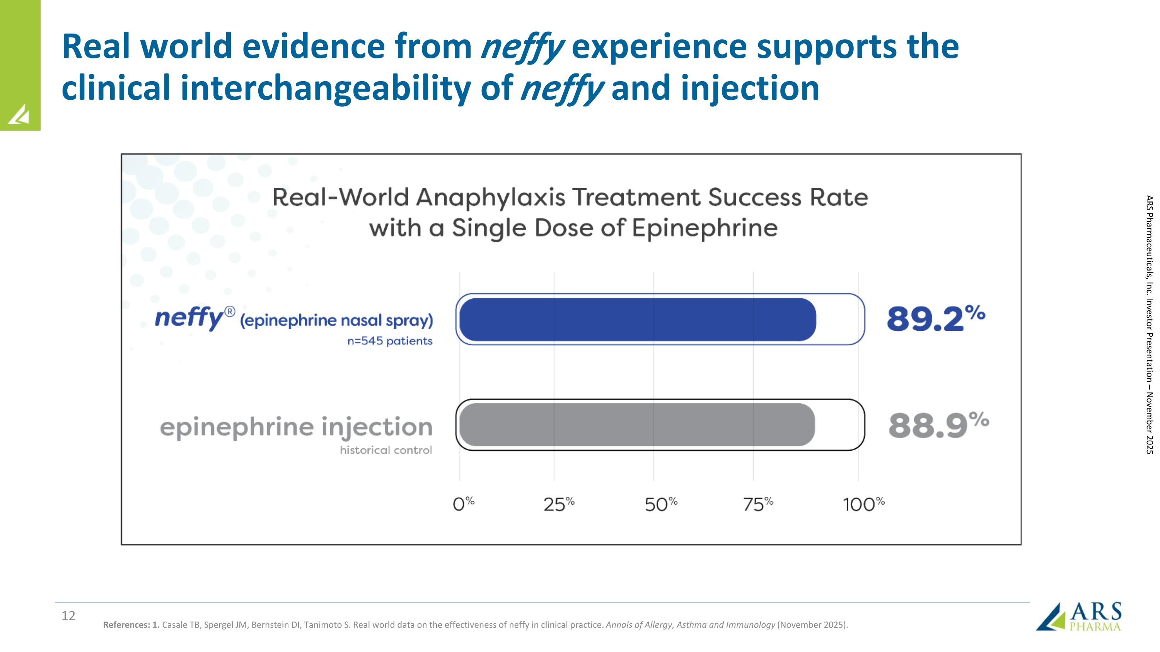
Real world evidence from neffy experience supports the clinical interchangeability of neffy and injection References: 1. Casale TB, Spergel JM, Bernstein DI, Tanimoto S. Real world data on the effectiveness of neffy in clinical practice. Annals of Allergy, Asthma and Immunology (November 2025). ARS Pharmaceuticals, Inc. Investor Presentation – November 2025

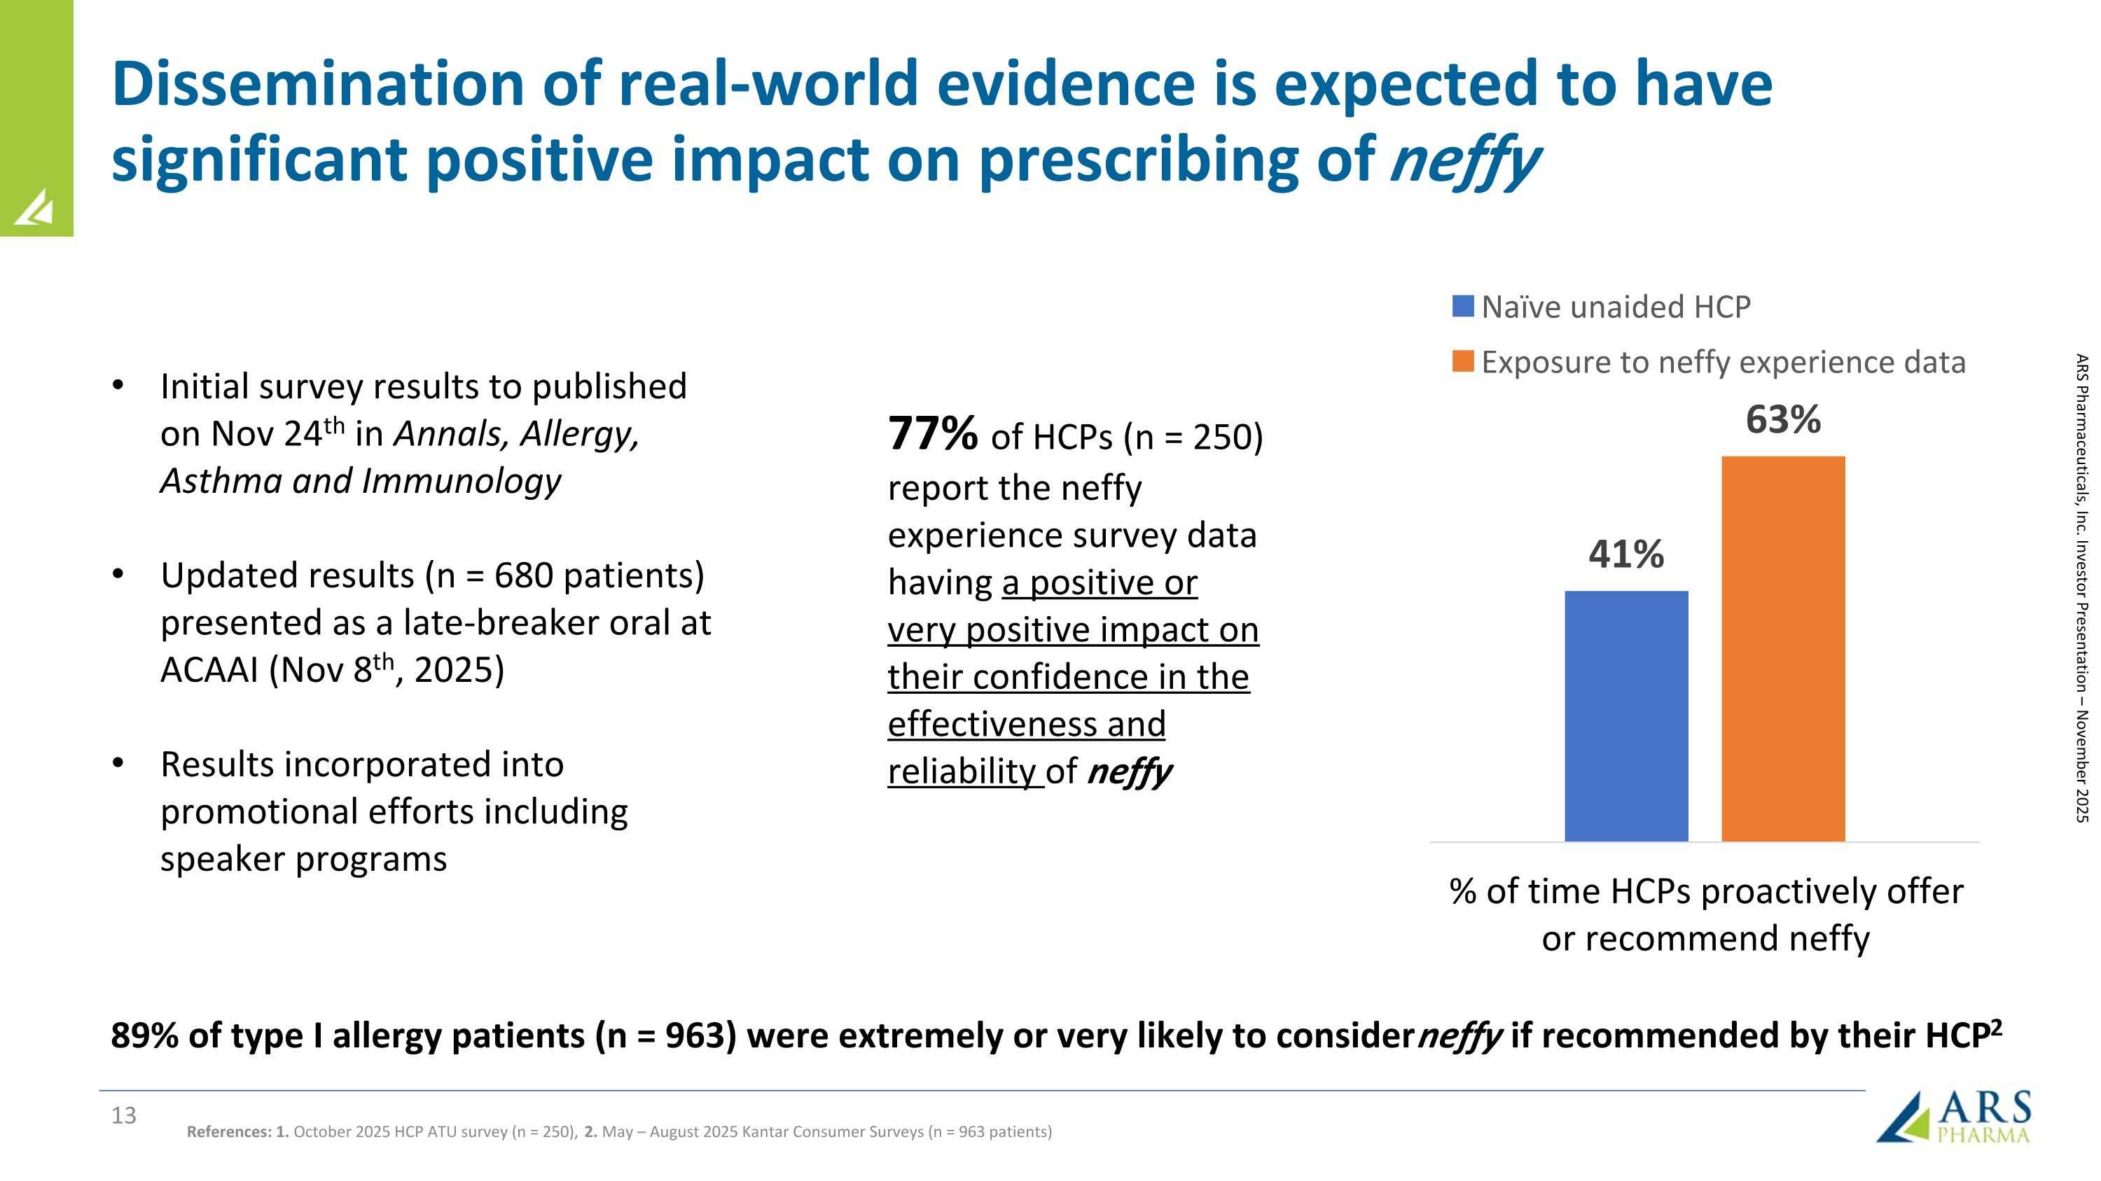
Dissemination of real-world evidence is expected to have significant positive impact on prescribing of neffy ARS Pharmaceuticals, Inc. Investor Presentation – November 2025 References: 1. October 2025 HCP ATU survey (n = 250), 2. May – August 2025 Kantar Consumer Surveys (n = 963 patients) 89% of type I allergy patients (n = 963) were extremely or very likely to consider neffy if recommended by their HCP2 Initial survey results to published on Nov 24th in Annals, Allergy, Asthma and Immunology Updated results (n = 680 patients) presented as a late-breaker oral at ACAAI (Nov 8th, 2025) Results incorporated into promotional efforts including speaker programs 77% of HCPs (n = 250) report the neffy experience survey data having a positive or very positive impact on their confidence in the effectiveness and reliability of neffy

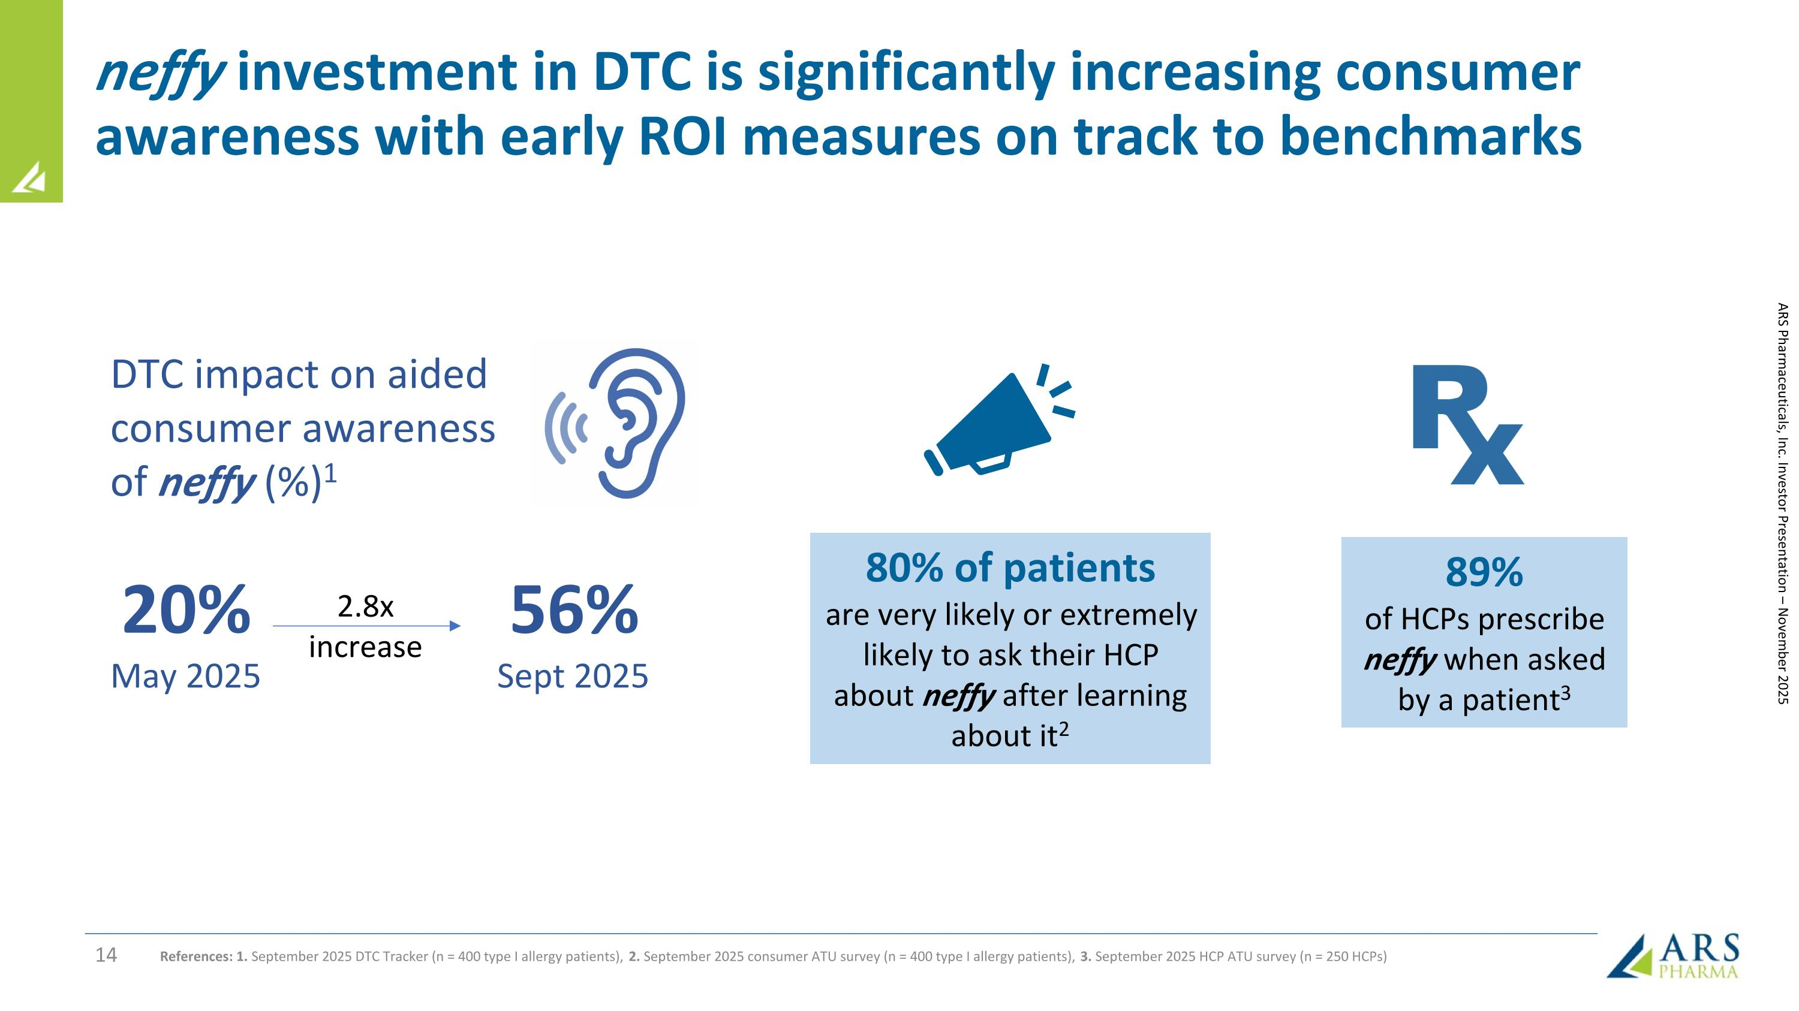
ARS Pharmaceuticals, Inc. Investor Presentation – November 2025 80% of patients are very likely or extremely likely to ask their HCP about neffy after learning about it2 89% of HCPs prescribe neffy when asked by a patient3 20% May 2025 2.8x increase 56% Sept 2025 DTC impact on aided consumer awareness of neffy (%)1 References: 1. September 2025 DTC Tracker (n = 400 type I allergy patients), 2. September 2025 consumer ATU survey (n = 400 type I allergy patients), 3. September 2025 HCP ATU survey (n = 250 HCPs) neffy investment in DTC is significantly increasing consumer awareness with early ROI measures on track to benchmarks

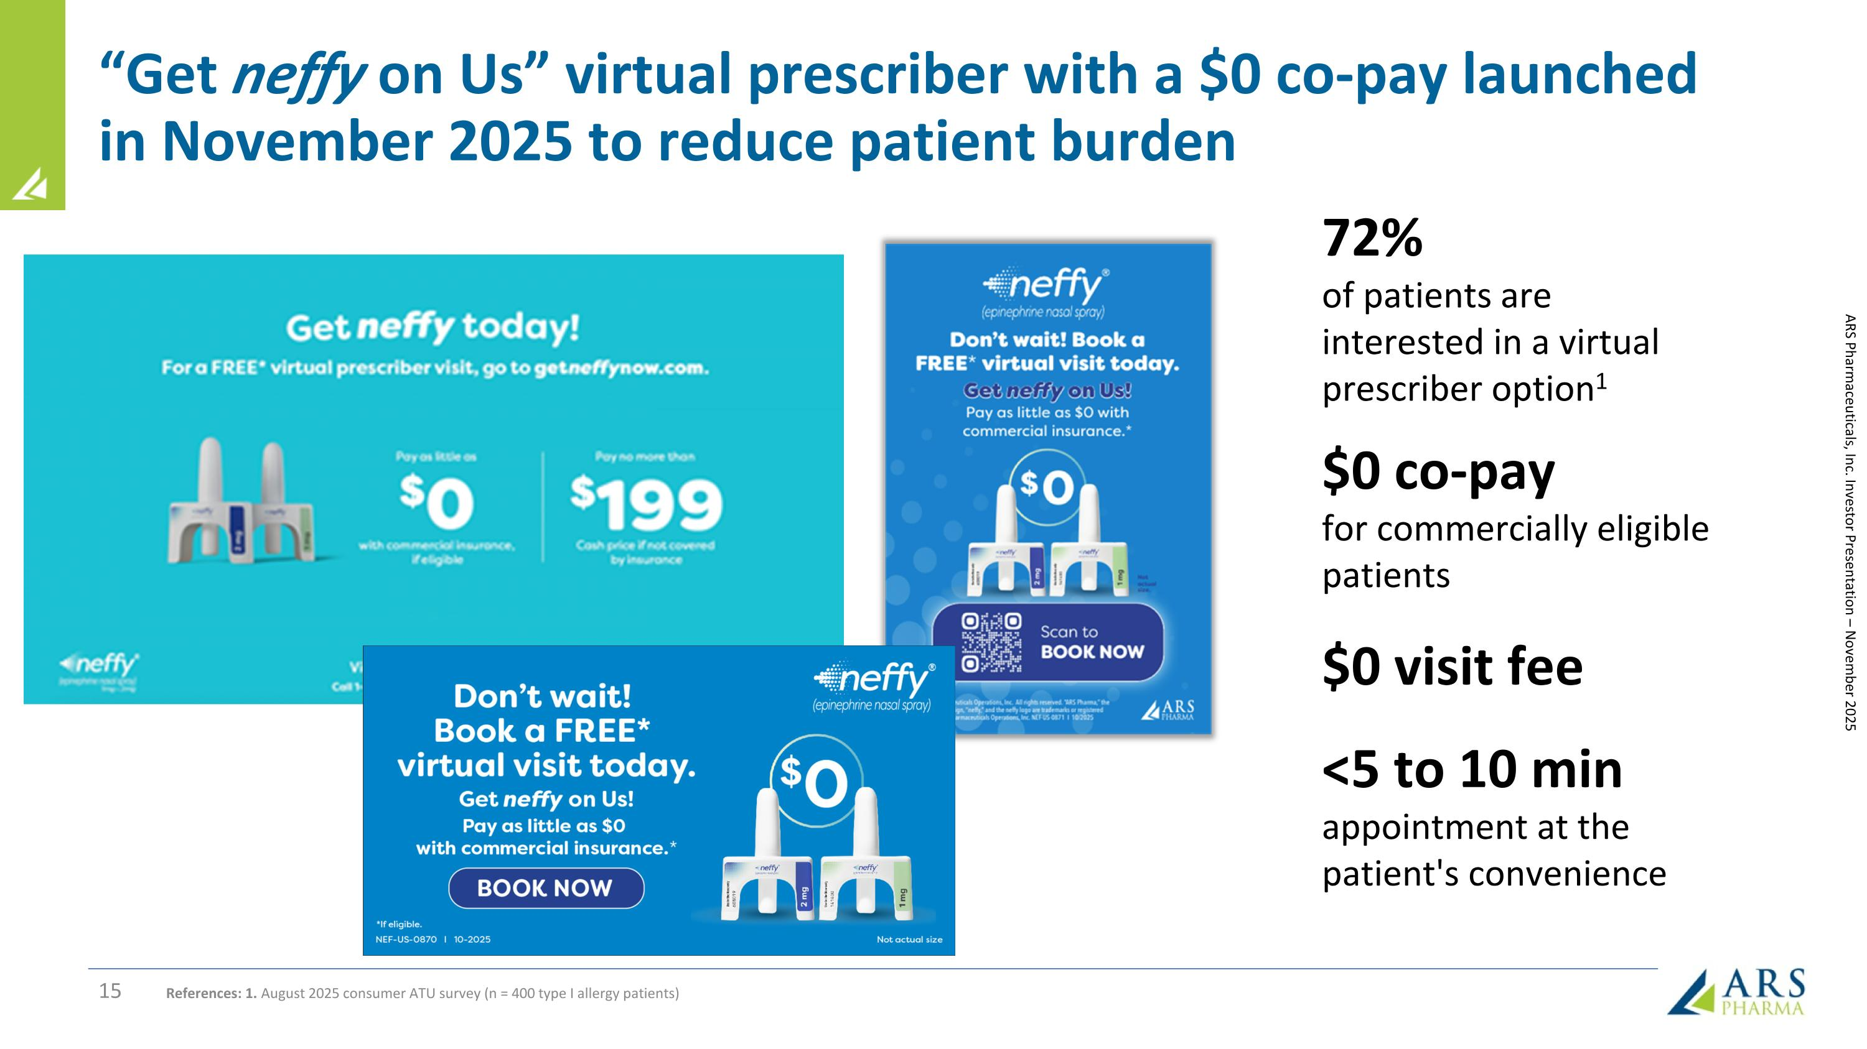
ARS Pharmaceuticals, Inc. Investor Presentation – November 2025 72% of patients are interested in a virtual prescriber option1 $0 co-pay for commercially eligible patients $0 visit fee <5 to 10 min appointment at the patient's convenience References: 1. August 2025 consumer ATU survey (n = 400 type I allergy patients) “Get neffy on Us” virtual prescriber with a $0 co-pay launched in November 2025 to reduce patient burden

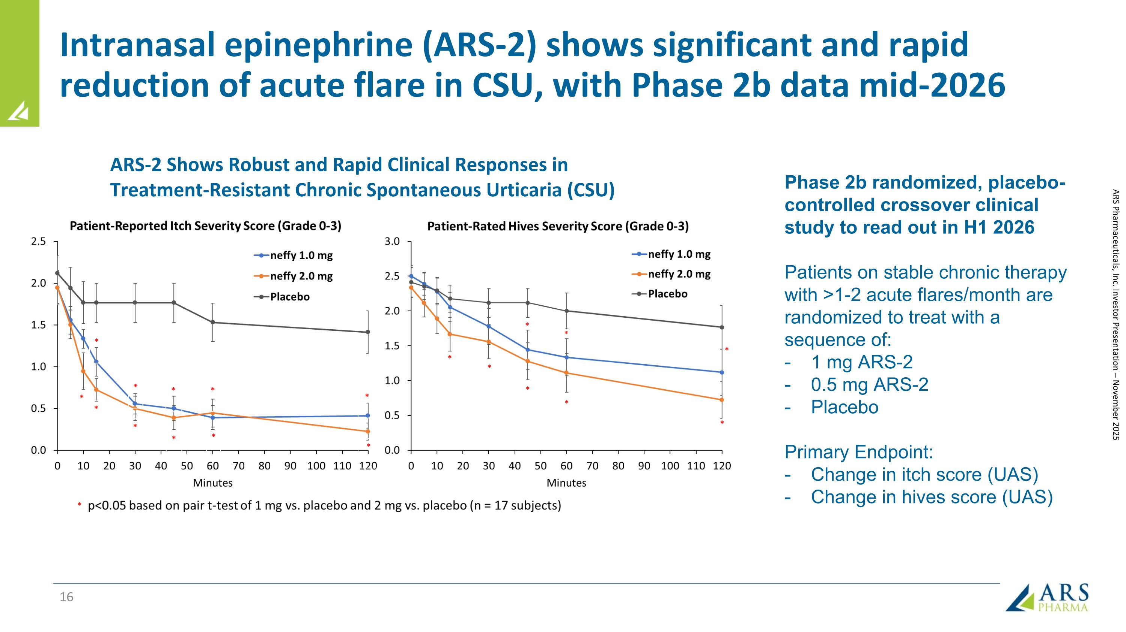
Intranasal epinephrine (ARS-2) shows significant and rapid reduction of acute flare in CSU, with Phase 2b data mid-2026 Phase 2b randomized, placebo-controlled crossover clinical study to read out in H1 2026 Patients on stable chronic therapy with >1-2 acute flares/month are randomized to treat with a sequence of: 1 mg ARS-2 0.5 mg ARS-2 Placebo Primary Endpoint: Change in itch score (UAS) Change in hives score (UAS) ARS Pharmaceuticals, Inc. Investor Presentation – November 2025 ARS-2 Shows Robust and Rapid Clinical Responses in Treatment-Resistant Chronic Spontaneous Urticaria (CSU)

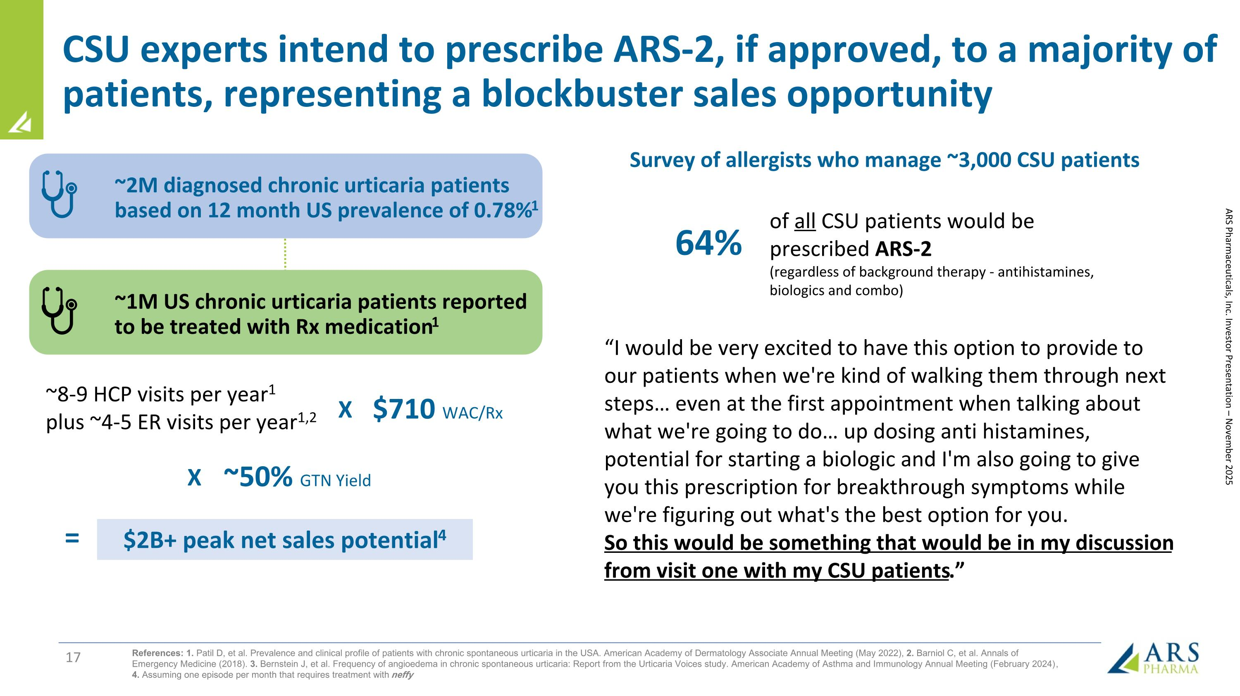
CSU experts intend to prescribe ARS-2, if approved, to a majority of patients, representing a blockbuster sales opportunity of all CSU patients would be prescribed ARS-2 (regardless of background therapy - antihistamines, biologics and combo) ~2M diagnosed chronic urticaria patients based on 12 month US prevalence of 0.78%1 ~1M US chronic urticaria patients reported to be treated with Rx medication1 ~8-9 HCP visits per year1 plus ~4-5 ER visits per year1,2 $710 WAC/Rx ~50% GTN Yield $2B+ peak net sales potential4 X X = ARS Pharmaceuticals, Inc. Investor Presentation – November 2025 References: 1. Patil D, et al. Prevalence and clinical profile of patients with chronic spontaneous urticaria in the USA. American Academy of Dermatology Associate Annual Meeting (May 2022), 2. Barniol C, et al. Annals of Emergency Medicine (2018). 3. Bernstein J, et al. Frequency of angioedema in chronic spontaneous urticaria: Report from the Urticaria Voices study. American Academy of Asthma and Immunology Annual Meeting (February 2024) , 4. Assuming one episode per month that requires treatment with neffy “I would be very excited to have this option to provide to our patients when we're kind of walking them through next steps even at the first appointment when talking about what we're going to do up dosing anti histamines, potential for starting a biologic and I'm also going to give you this prescription for breakthrough symptoms while we're figuring out what's the best option for you. So this would be something that would be in my discussion from visit one with my CSU patients.” 64% Survey of allergists who manage ~3,000 CSU patients

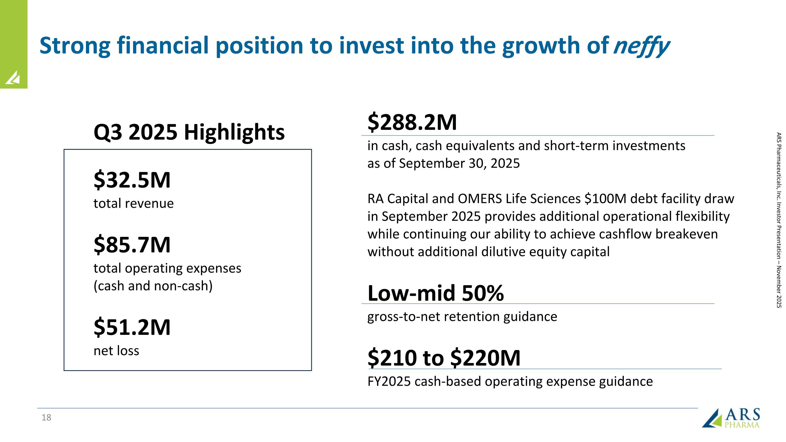
Strong financial position to invest into the growth of neffy $288.2M in cash, cash equivalents and short-term investments as of September 30, 2025 RA Capital and OMERS Life Sciences $100M debt facility draw in September 2025 provides additional operational flexibility while continuing our ability to achieve cashflow breakeven without additional dilutive equity capital Low-mid 50% gross-to-net retention guidance $210 to $220M FY2025 cash-based operating expense guidance Q3 2025 Highlights $32.5M total revenue $85.7M total operating expenses (cash and non-cash) $51.2M net loss ARS Pharmaceuticals, Inc. Investor Presentation – November 2025

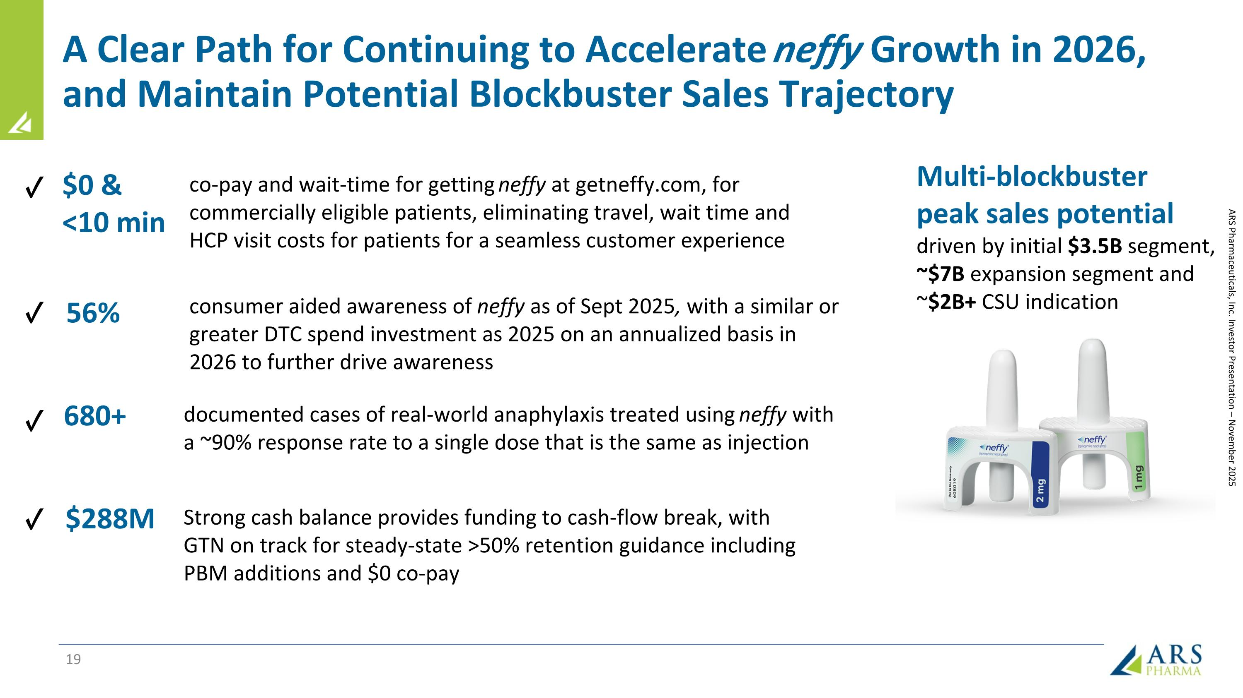
A Clear Path for Continuing to Accelerate neffy Growth in 2026, and Maintain Potential Blockbuster Sales Trajectory Multi-blockbuster peak sales potential driven by initial $3.5B segment, ~$7B expansion segment and ~$2B+ CSU indication ARS Pharmaceuticals, Inc. Investor Presentation – November 2025 680+ documented cases of real-world anaphylaxis treated using neffy with a ~90% response rate to a single dose that is the same as injection 56% consumer aided awareness of neffy as of Sept 2025, with a similar or greater DTC spend investment as 2025 on an annualized basis in 2026 to further drive awareness $0 & <10 min co-pay and wait-time for getting neffy at getneffy.com, for commercially eligible patients, eliminating travel, wait time and HCP visit costs for patients for a seamless customer experience $288M Strong cash balance provides funding to cash-flow break, with GTN on track for steady-state >50% retention guidance including PBM additions and $0 co-pay ✓ ✓ ✓ ✓

